Year 10 Practice exam Mid Year

Question 1
Simplify the following:
(a) (d ⁴f )⁵
(b) (2u⁰d ³)⁶

Question 2
Simplify the following:
(a) (t⁵f )³
(b) (4u⁰z²)⁵

Question 3
Simplify the following:
(a)
(b)

Question 4
Simplify the following:
(a)
(b)

Question 5
Simplify the following, expressing the answers with positive indices.
(a)
(b)

Question 6
Simplify the following, expressing the answers with positive indices.
(a)
(b)

Question 7
Write each of the following in index form as a single power:
(a)
(b)

Question 8
Write each of the following in index form as a single power:
(a)
(b)

Question 9
Evaluate the following:
(a) 8^{4/3}
(b) 16^{3/4}

Question 10
Evaluate the following:
(a) 25^{5/2}
(b) 81^{3/4}

Question 11
Simplify the following expressions:
(a)
(b)

Question 12
Simplify the following expressions:
(a)
(b)

Question 13
Find the area of this shape:

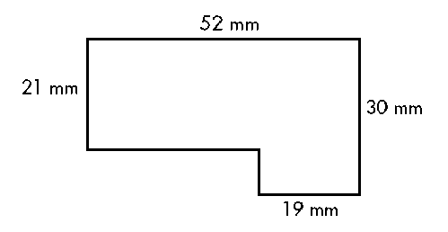

Question 14
Find the area of this shape:

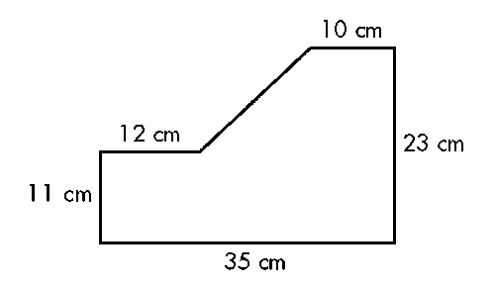

Question 15
What is the surface area of a cylinder 40 cm long and 18 cm in diameter? Answer correct to two decimal places.

Question 16
What is the surface area of a cylinder 50 mm long and 30 mm in diameter? Answer correct to one decimal place.

Question 17
Find the volume of these solids to the nearest whole number:
(a)
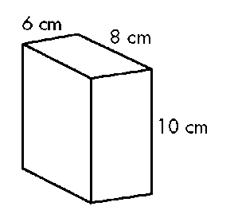
(b)
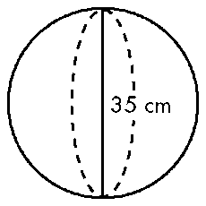

Question 18
Find the volume of these solids to the nearest whole number:
(a)
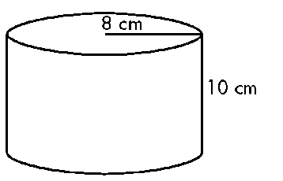
(b)
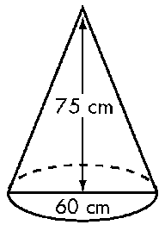

Question 25
Use the difference of two squares rule to expand the following expressions:
(a) (x + 4)(x − 4)
(b) (5a − 3)(5a + 3)

Question 26
Use the perfect squares rule to expand the following expressions:
(a) (x + 2)²
(b) (7a − 2)²

Question 27
Factorise the following expressions:
(a) 10ab – 6a²
(b) 12x² – 8xy + 20x²y

Question 28
Factorise the following expressions:
(a) 12ab + 10a²

Question 29
Factorise the following:
(a) x2 – 100
(b) 16x² – 25y2

Question 30
Factorise the following:
(a) a² – 64
(b) 36x² – 121y2

Question 31
Using the perfect squares rule, factorise the following expressions:
(a) x² + 12x + 36
(b) 36x² − 84x + 49

Question 32
Using the perfect squares rule, factorise the following expressions:
(a) x² + 14x + 49
(b) 49x² − 28x + 4

(b) 24x² – 12xy – 18x²y

